Nome: André Luiz N. Carneiro De Castro RA: 92854
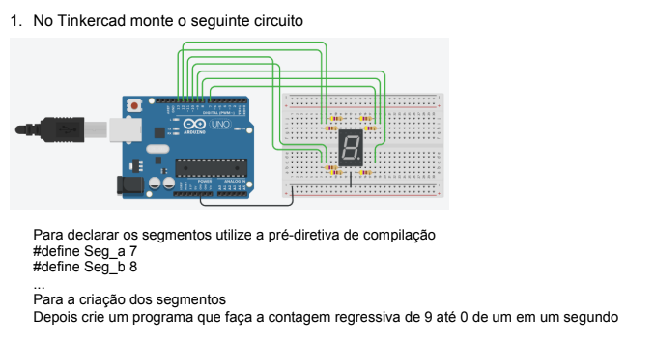

Link: https://www.tinkercad.com/things/jJXyAdm0o3T

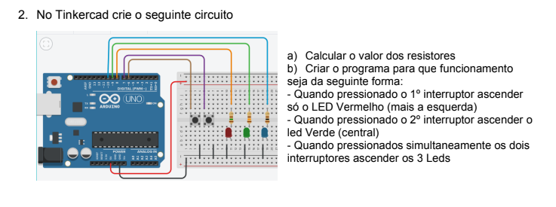
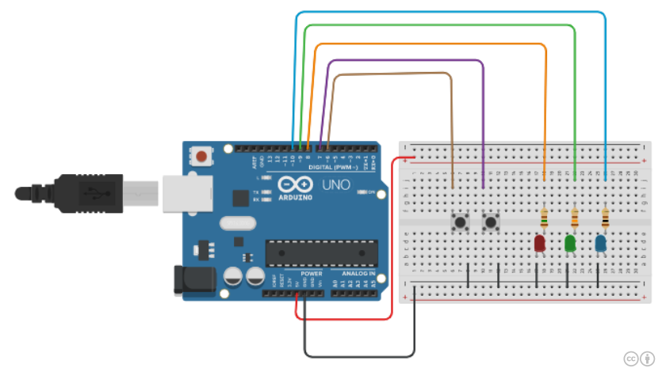
Link: https://www.tinkercad.com/things/8faoU2IXfNf

